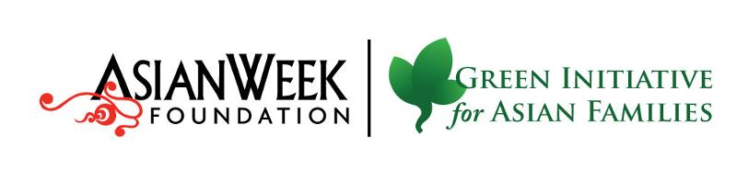

***** FOR IMMEDIATE RELEASE *******

Contact: Angela Pang, (415) 691-7264

Historic First Harvest at
San Francisco's Asian Community Garden

- City’s newest urban farm grows Soy Beans, Bok Choy, Chinese Cabbage, Bunching Onions, Cilantro, Tatsoi, Pai Choi, French Radish and other varieties-

San Francisco, CA (April 11, 2015) – City officials, community leaders and volunteer gardeners gathered at the Florence Fang Asian Community Garden to celebrate the first harvest of Asian vegetables grown by local residents.

Sai Ming Kwok is 68 years old and has been volunteering at the garden for almost a whole year now. “xxxxxx”. Kwok has been in San Francisco since 1978 and doesn’t speak English.

The project is the first community garden in San Francisco to focus on the Asian community, and sitting on a one-acre lot under a long-lease from CalTrains, it is the newest and will be one of the largest urban farms in the City. It also reflects the growing diversity of the Southeastern neighborhoods of San Francisco with volunteers of all ages and colors participating. A recent flier was translated into English, Chinese and Spanish.

Faheem Carter, 26, is a lifelong Bayview resident and a horticultural student at City College. “We welcome all residents, including, African American, white and Mexican people,” said Carter. “I believe that this garden will bring families together and let families enjoy a fresh meal. We just had our first crop. We plan on growing a bigger selection that includes good varieties of native California vegetation.”

The project has been supported by many local businesses donating gravel, compost and tools. Grant funding has also been provided by Aetna Foundation, Recology, SF Association of Realtors and SF Dept. of Environment.

The Bayview/Hunters Point is one of San Francisco’s fastest demographically changing neighborhoods, with Asian/Pacific Islanders now the largest population group. Organizers found that 42 percent of households immediately surrounding the site are owned by Asian/Pacific Islanders. The site sits above an operational CalTrain tunnel and was home to the Diana Street Farm, San Francisco’s last farm.

San Francisco’s Bayview has been called a “food swamp” where food is available but not necessarily healthy, affordable or culturally appropriate. Asian immigrants are particularly challenged with new studies showing they have twice the risk of diabetes and some of the fastest-growing rates of obesity among all ethnic groups.

Volunteer days are held every 2nd and 4th Saturday, from 10 a.m. to 1 p.m. Sign up is online at www.tinyurl.com/AWFvolunteer.

###

About the Green Initiative for Asian Families

The Green Initiative for Asian Families (GIAF) is a project of the AsianWeek Foundation. GIAF is a network of Asian and Pacific Islander community-based organizations and service providers committed to developing a culturally proficient and inclusive approach to increasing sustainable practices.
AsianWeek Foundation is a non-profit 501(c)3 that encourages the sharing of differences and appreciation of diversity across culture, language, generation and ethnicity, and works to strengthen relations among Asian Pacific Islander communities and between Asians and non-Asians.

Advisory Partners: Asian Pacific American Community Center, Community Youth Center, San Francisco Community Empowerment Center, and Visitacion Valley Asian Alliance.
Community Partner: Quesada Gardens Initiative.

